Exercise 7-2

Jirayu Petchhan, D10907801

From Main_Angular.py

CE loss (default setting) for training



Performance

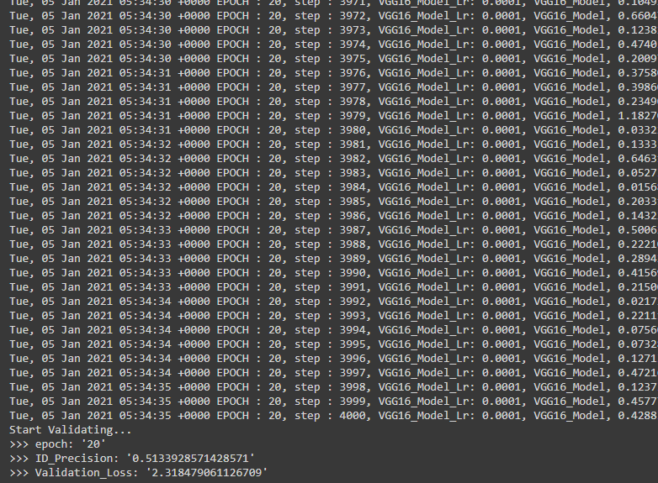

Changing to Angle Loss

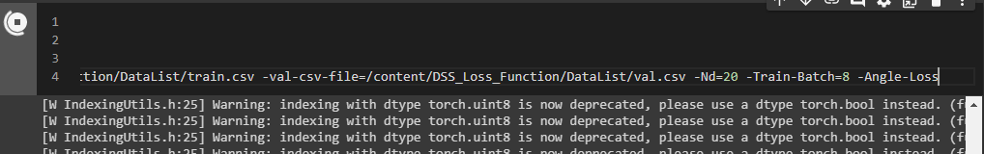

Performance

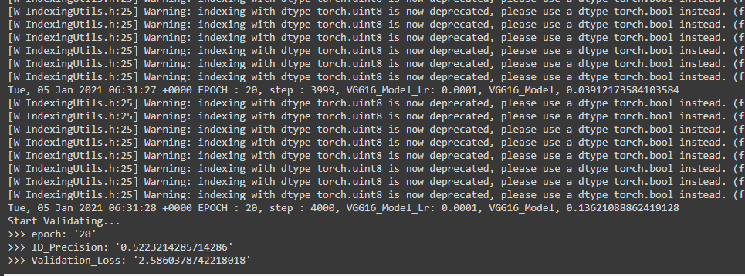

Snapshot path to use into feature compare



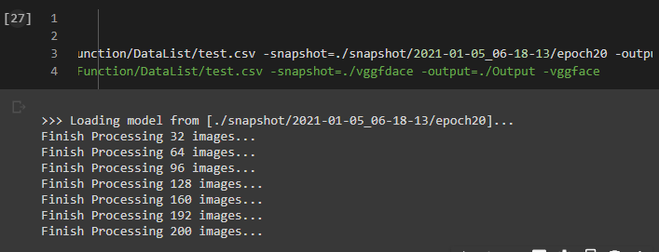

Feature compare path changed

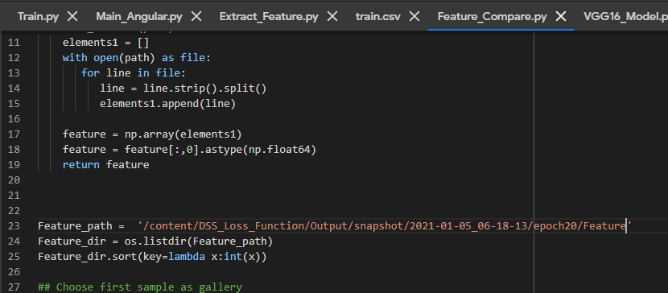

Feature compare testing (based on Angle Loss)

Accuracy

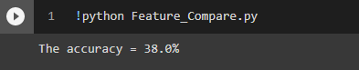

Test changing (Euclidean to cosine) and comparison

Default (Feature_Compare.py)

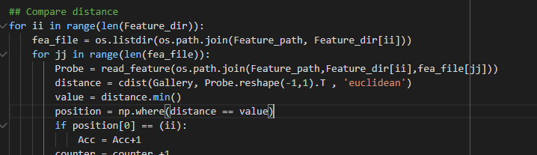

Changing

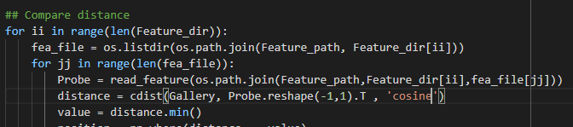

Post-test accuracy again

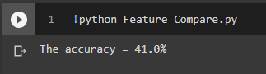

Result

Acc. from cosine has shown that is rather than Acc. from Euclidean method.